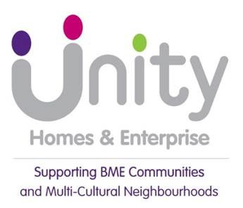
Annual Report
to tenants 2019-20
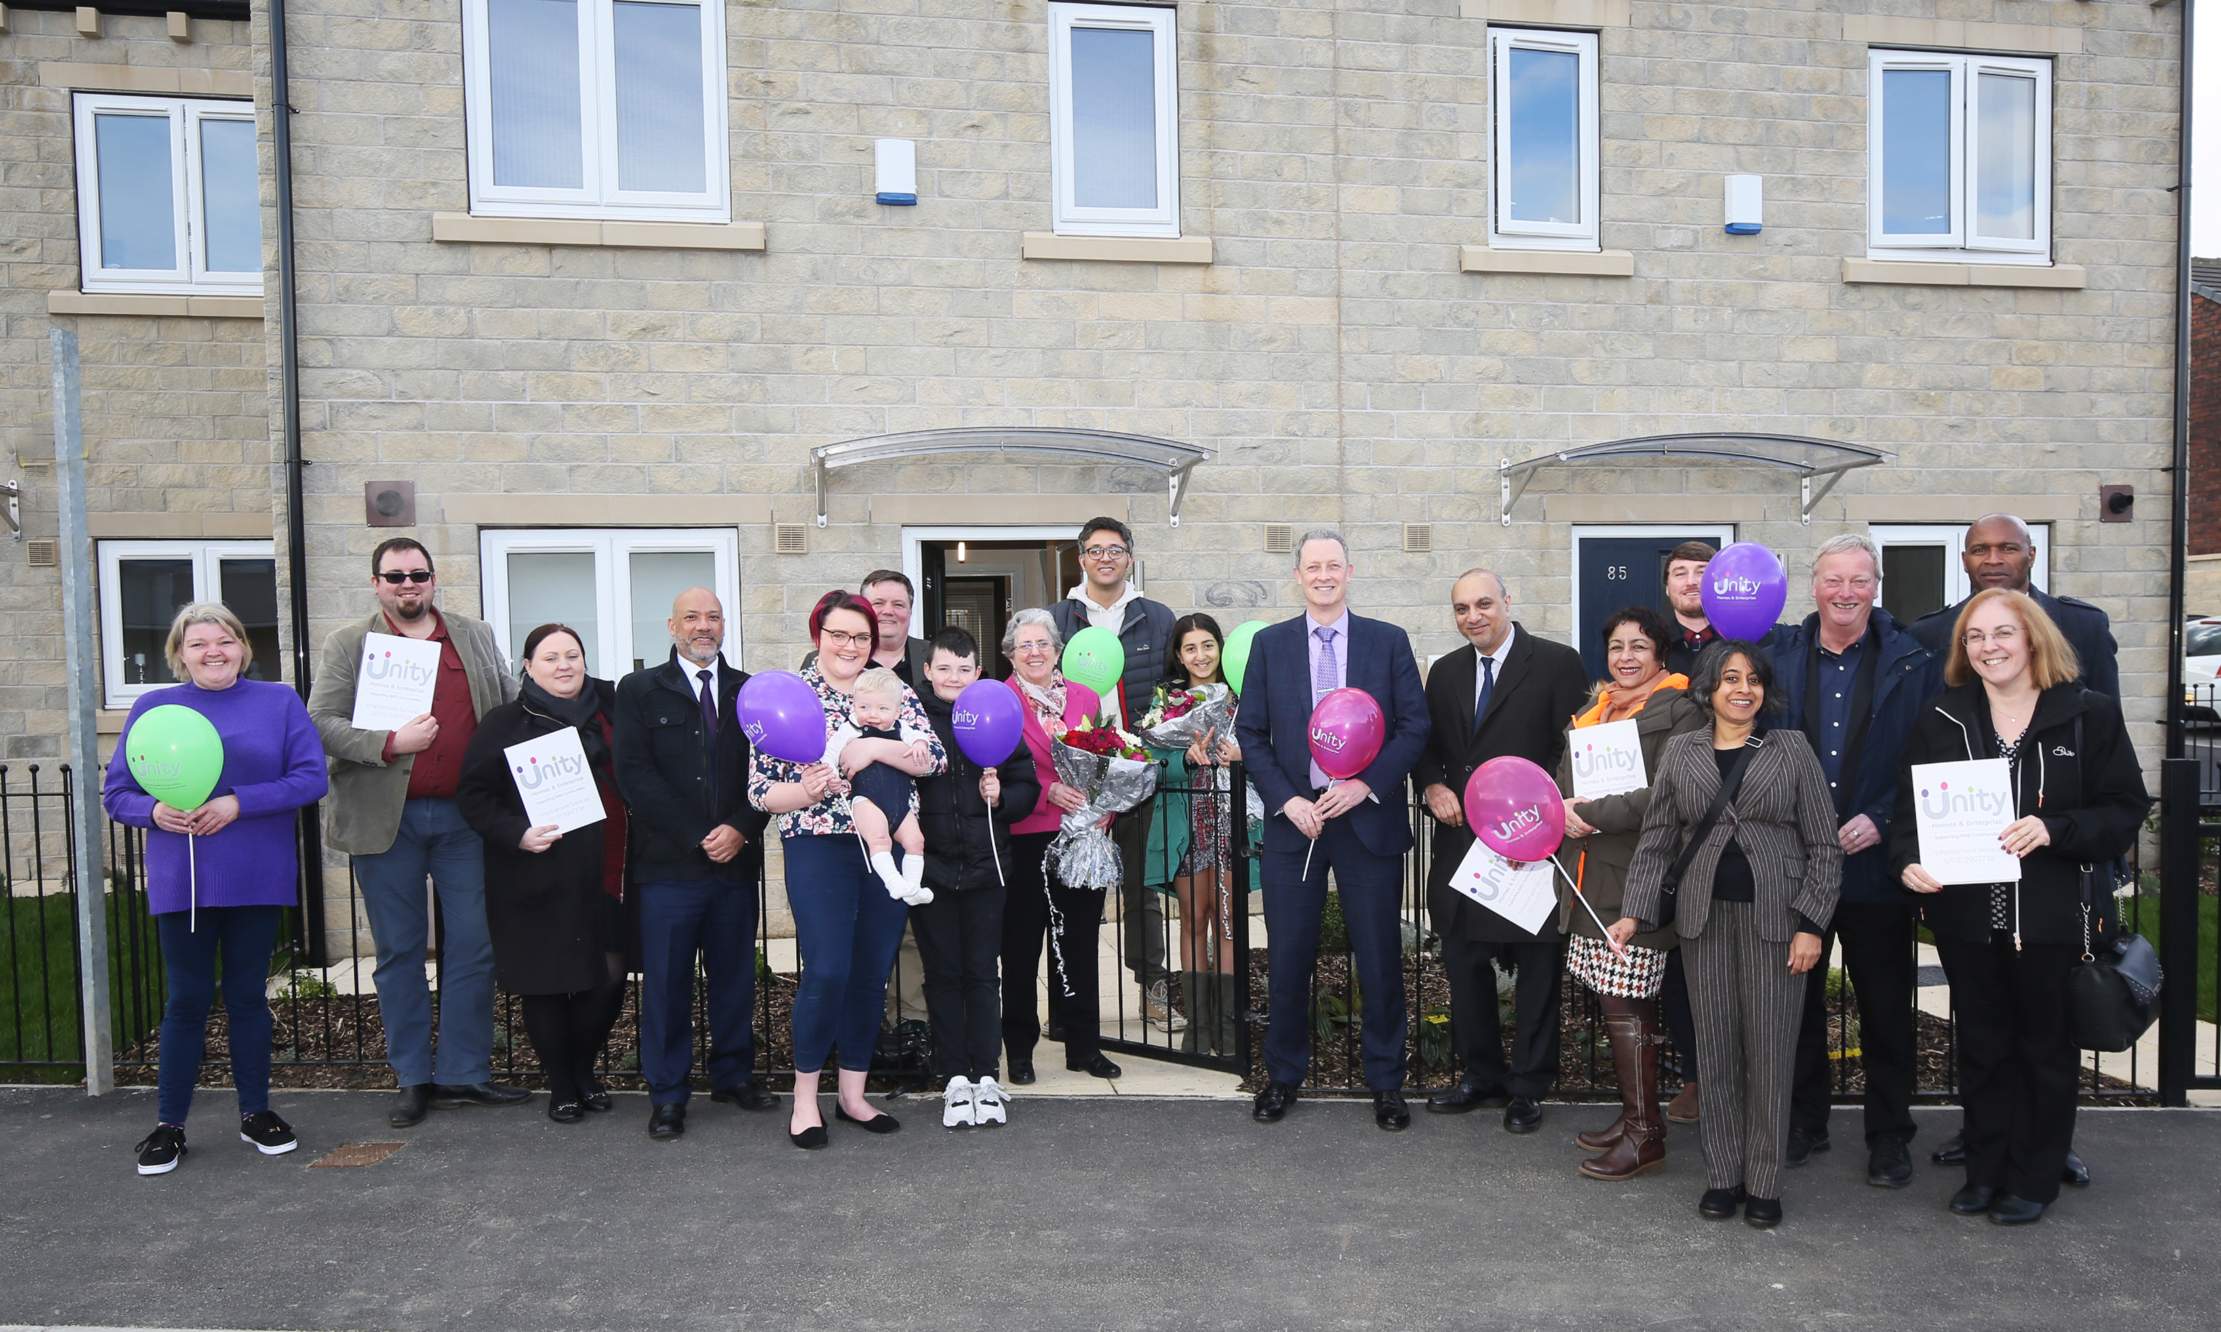

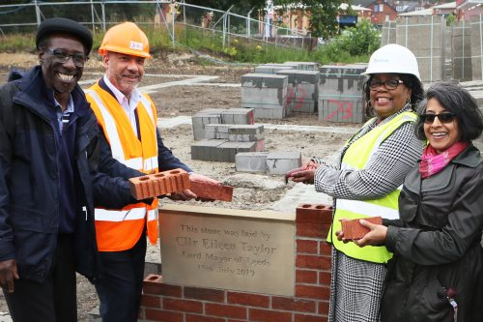

Unity 2019 – 20 Year Overview
2019-20 has seen Unity sustain another successful year, with the work to promote sustainable communities proving even more important with the challenges faced with the onset of a global health pandemic. Overall, the organisation is expanding in growth and geographically with a number of new developments. We look forward to delivering more affordable homes in the forthcoming year.

In February 2019 the National Housing Federation set out a draft 4 point action plan for delivering change across the social housing sector called Together with Tenants. The 4 proposed actions of the Together with Tenants plan are: New requirement in the Code of Governance, Together with Tenants Charter, Tenant and resident oversight and scrutiny and Closer links to regulation.

From July 2019 to March 2020 the Together with Tenants Action Plan and Charter were tested by 133 housing associations. We expect the government to publish its white paper laying out what action will be taken to rebalance the relationship between landlords and tenants before the end of the year. We have always valued the strong connection Unity has with its tenants and will continue to work with our tenants on ensuring they have a strong voice in regulating the services we provide.

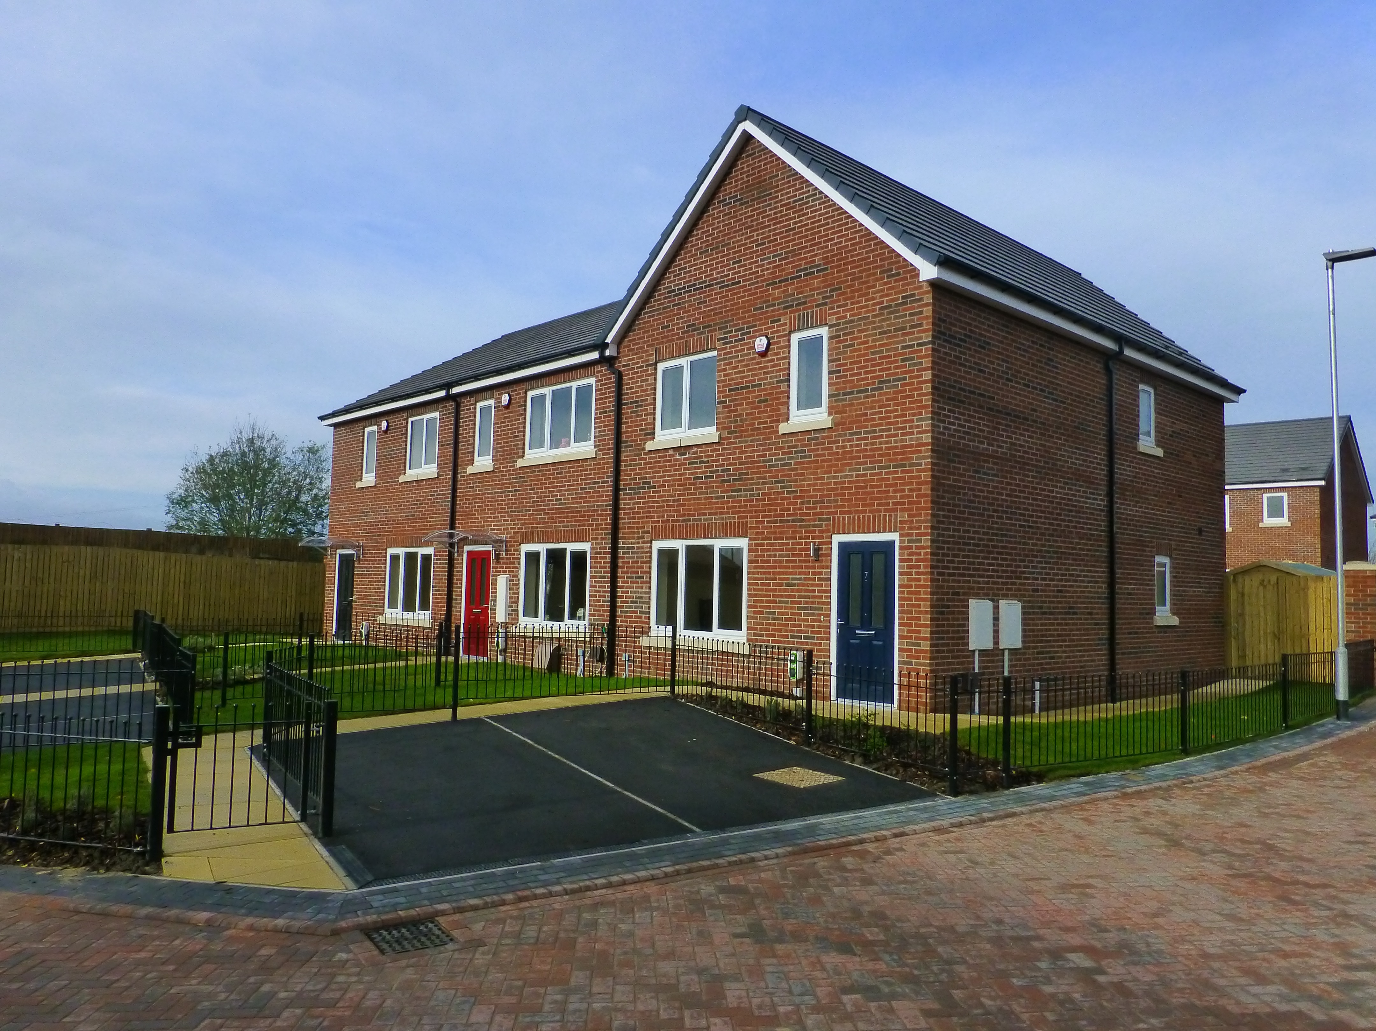
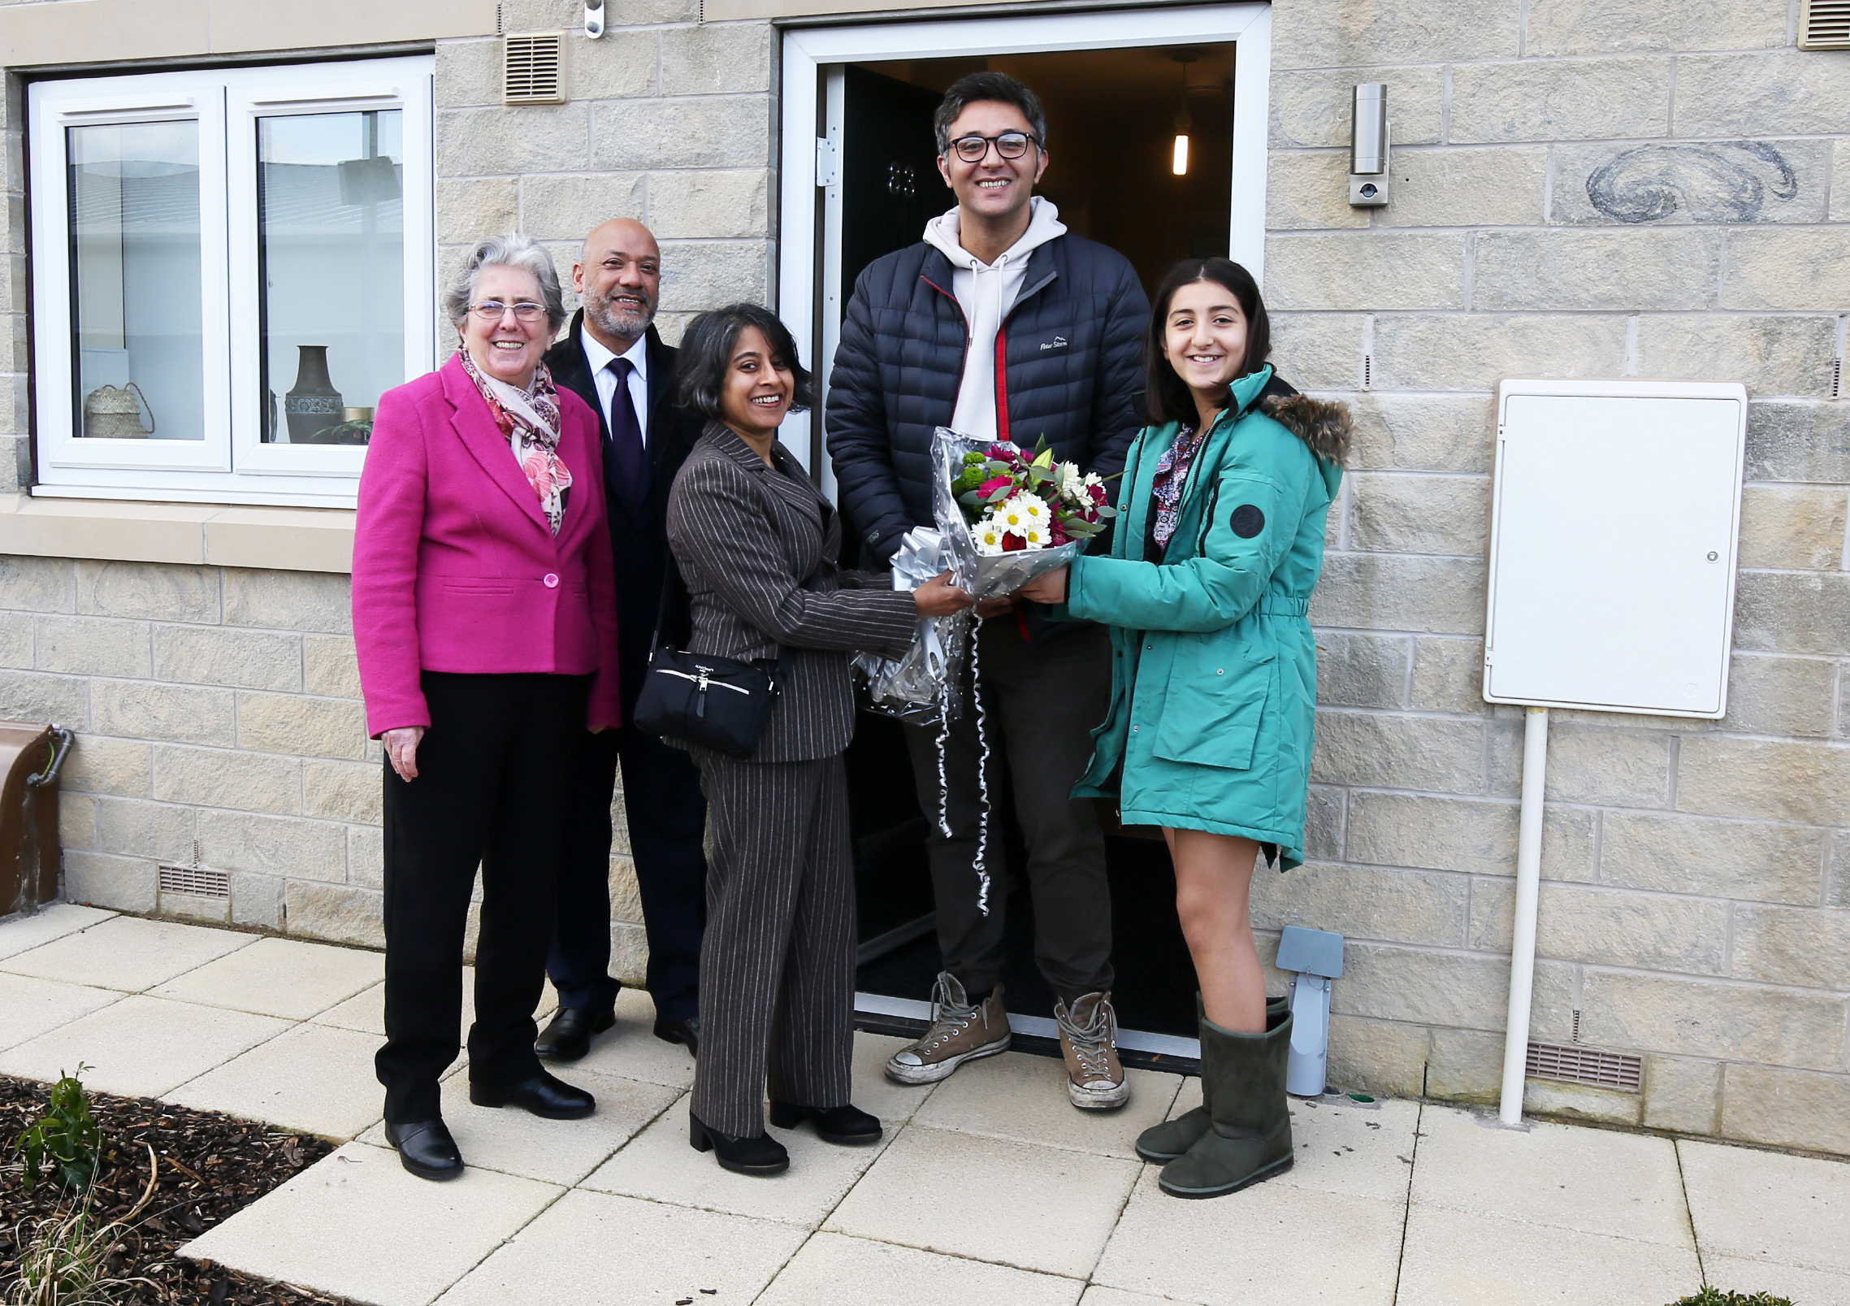
We have now embedded in our new maintenance and repairs contractor Gtd maintenance who are providing an excellent service to our tenants in 2019-20 they received a 95.1% satisfaction rate for service delivery and we will continue to review the services they provide to increase tenant satisfaction.
In 2019-20 we started our 3 year plan on completing the delivery of an additional 109 new homes. This has been Unity’s most ambitious development plan to date with a total of 220 new homes being delivered in partnership with Homes England. New homes have been added to our housing stock in Kippax Leeds and we have continued to add to our portfolio outside of Leeds with new homes being delivered in Cleakheaton. We also saw the start of a new housing development in partnership with Chapeltown Co-Housing Group which will see Unity acquire thirty 1 & 2 bedroom flats for people aged over 55.
We have expanded our housing management team which now consists of 3 income officers and 3 housing management officers to ensure that we have the capability to manage customer enquiries as the number of homes we manage increases. At the end of 2019-20 we now manage 1324 homes.

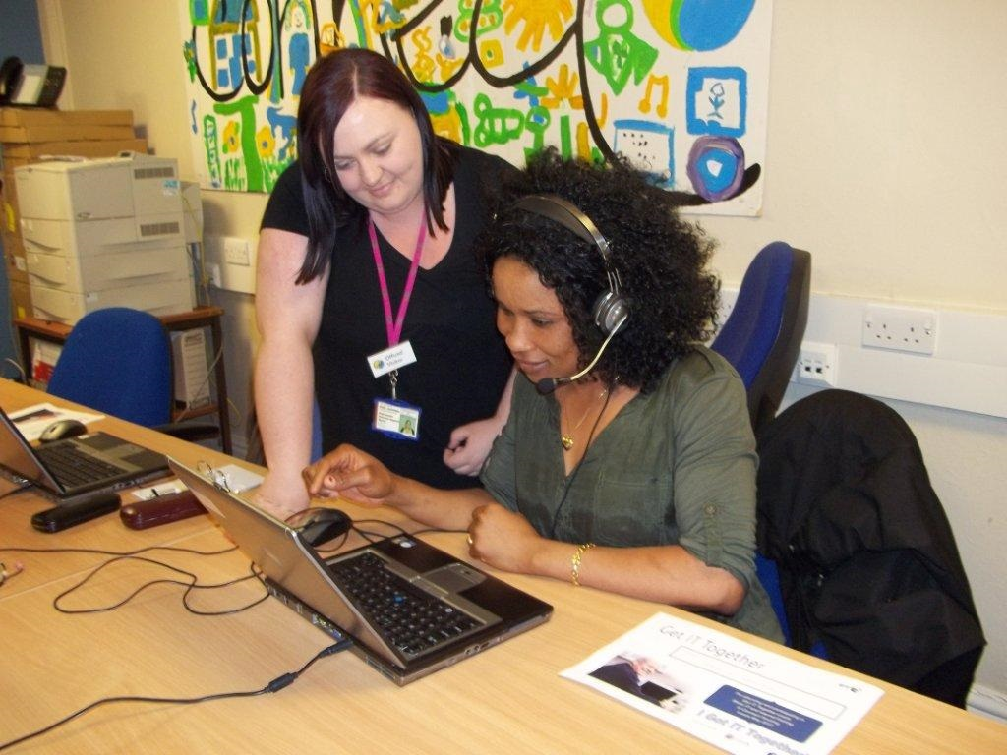

In November 2019 Unity was reaffirmed as achieving a G1V1 rating (G=Governance, V=Viability), by the Regulator of Social Housing (RoSH).
Unity currently holds a silver accreditation for Investors In People reflecting the importance we place on investment in staff training and development. In 2019-20 after an assessment of our services we maintained our Customer Service Excellence Award.

Our repairs and maintenance team have continued to provide a service to customers whilst adhering to social distance requirements with the focus on ensuring the safety of our customers. We have asked our customers if they are shielding or have any health conditions prior to any appointments and our staff and contractors have full PPE equipment provided.
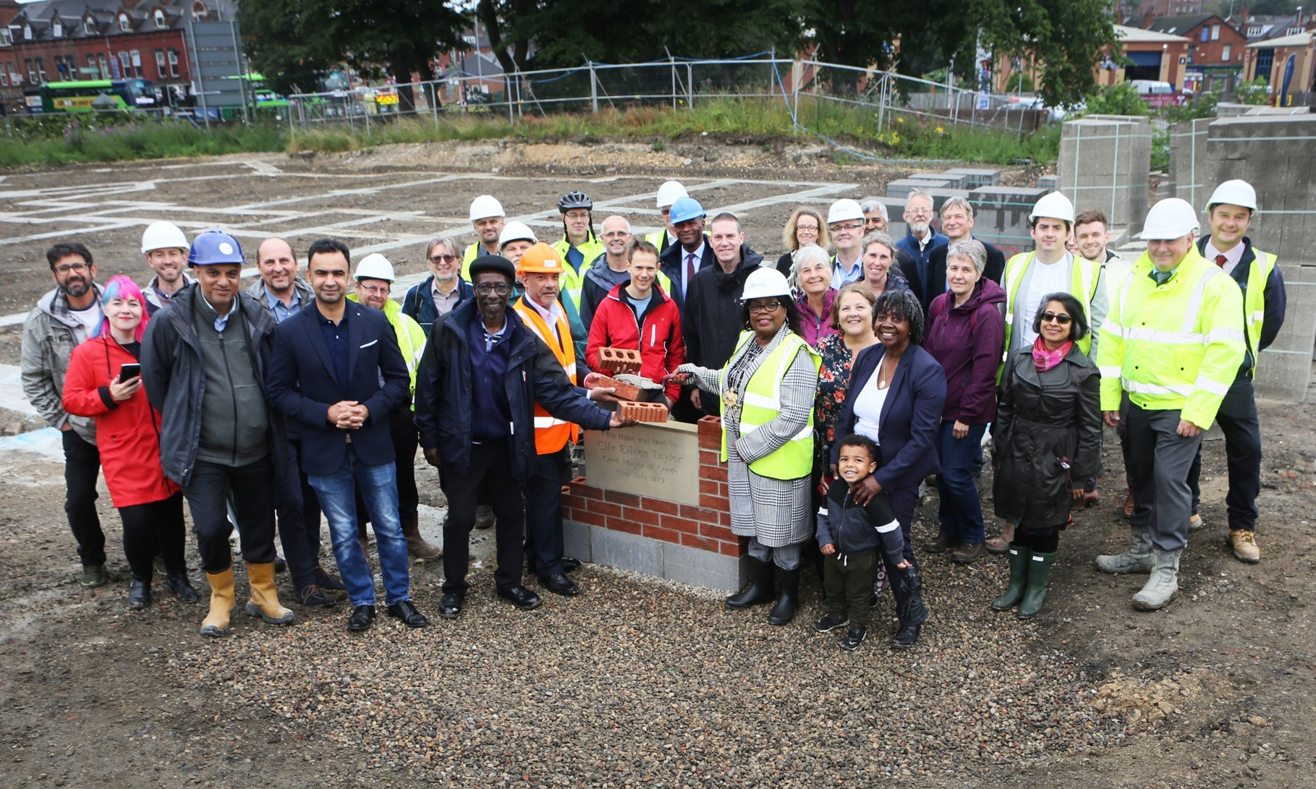
Towards the end of the year we were faced with the challenges brought about by the Covid-19 pandemic with our office being closed to the public and our staff working from home. Our focus has been to maintain services for customers whilst supporting our customers through this difficult time. We have contacted vulnerable customers and have advised people on how to maximise their income by claiming benefits, promoting the services of support agencies in our calls to customers and also providing information about the help available from the local authorities on our website. We have also organised referrals to local foodbanks.
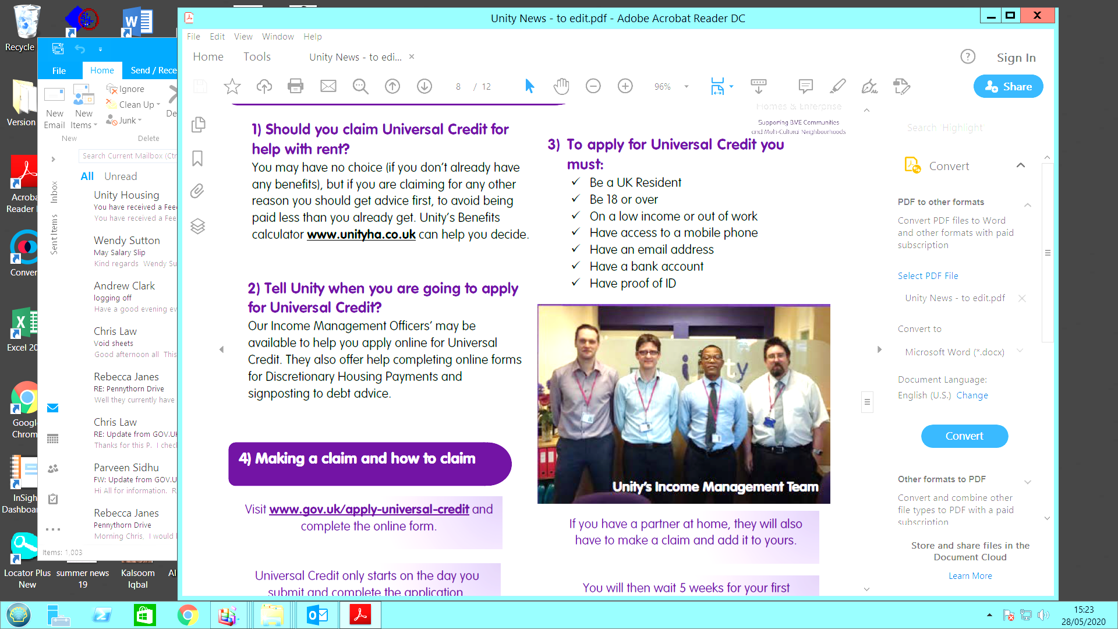
Rent Collection and Letting Performance

Rent loss from empty properties was 0.56% which achieved our target of being less than the National average of 1%

Housing Stock turnover was low at 3.98% this indicates that people are happy in their homes and we have sustainable communities
Highlights

Lettings to BME applicants were 44.9% this figure was influenced by our new developments being subject to Leeds City Council lettings criteria of having a local connection to the area which was not a factor for BME applicants.
Income collection increased to 101.46% up on the previous year’s total of 101.01%. The income management team have used the computer package Rentsense in order to identify trends in arrears and assist those in financial difficulty.

The average number of days to let each property was 28.8 days for 2019-20 this was higher than the target of 20 days.
Rent arrears as a % of rent roll has increased to 4.18%, for the majority of the year it was predicted that we would hit target of 3.91% however the impact of the Covid-19 pandemic increased arrears in the final month of collection.
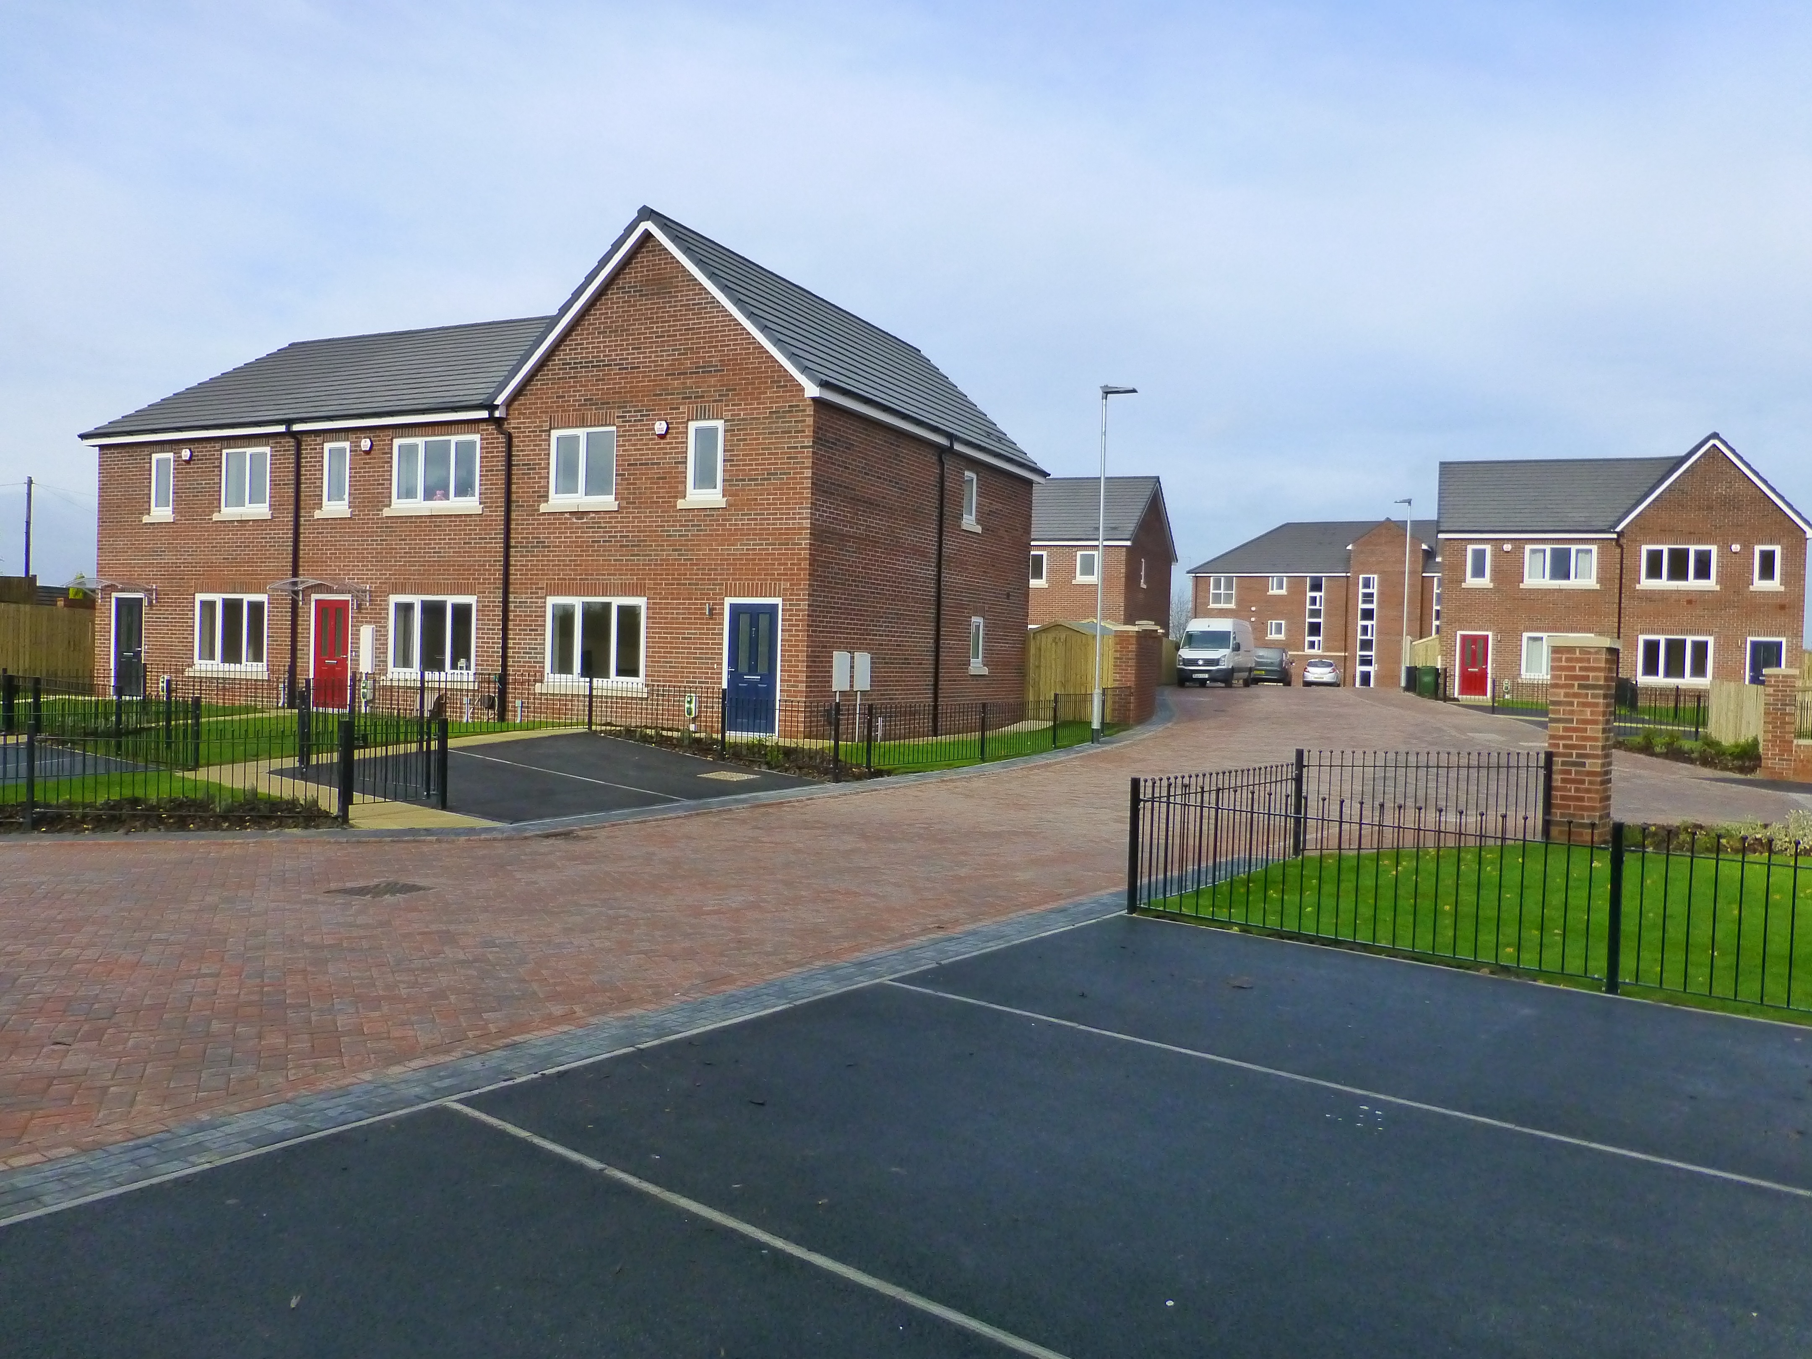

Highlights

Maintenance Performance

30 Fire safety checks were completed
98.7% of gas servicing was completed at year end

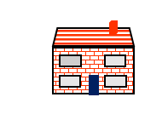


A total of £684,912 was spent on routine repairs

We carried out 4576 repairs on our properties throughout 2019-2020.

13.3% of repairs were Emergencies 37.7%
were Urgent and 49% were Routine
Routine repairs were carried out in 6.2 days
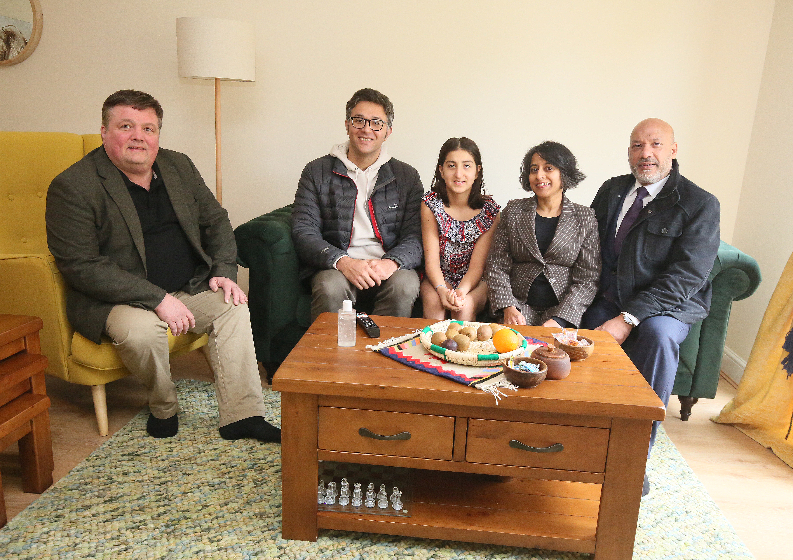
Gtd contractors managed to achieve a 95.1% customer satisfaction rate for repairs in 2019-20

174 Houses were painted externally

19 New windows were installed

69 New boilers were installed





Delivering Affordable Homes

Northgate Cleakheaton
In December 2019 our new development of 7 houses was completed at Cleakheaton, these 2 and 3 bedroom family homes add to our housing stock in Kirklees.
Chipesch Way Kippax
We took handover of 23 homes at our new development at Kippax in Leeds, the development consists of 11 2 and 3 bedroom houses as well as 12 flats for residents aged over 55.

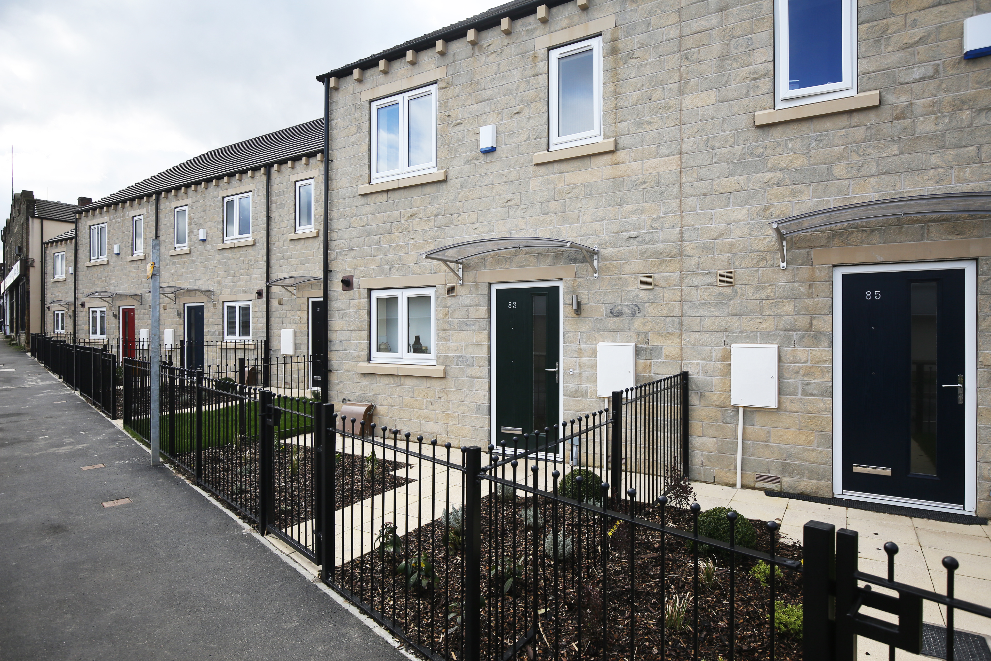
Upcoming Developments
Leopold Street
Beckhill Grove Meanwood
Adding to our existing stock in Meanwood there will be 30 new 2, 3 and 4 bedroom houses coming to Unity in spring 2020
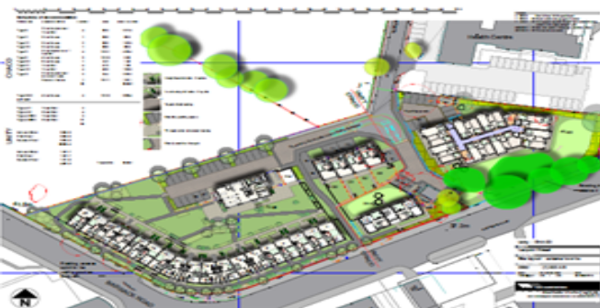

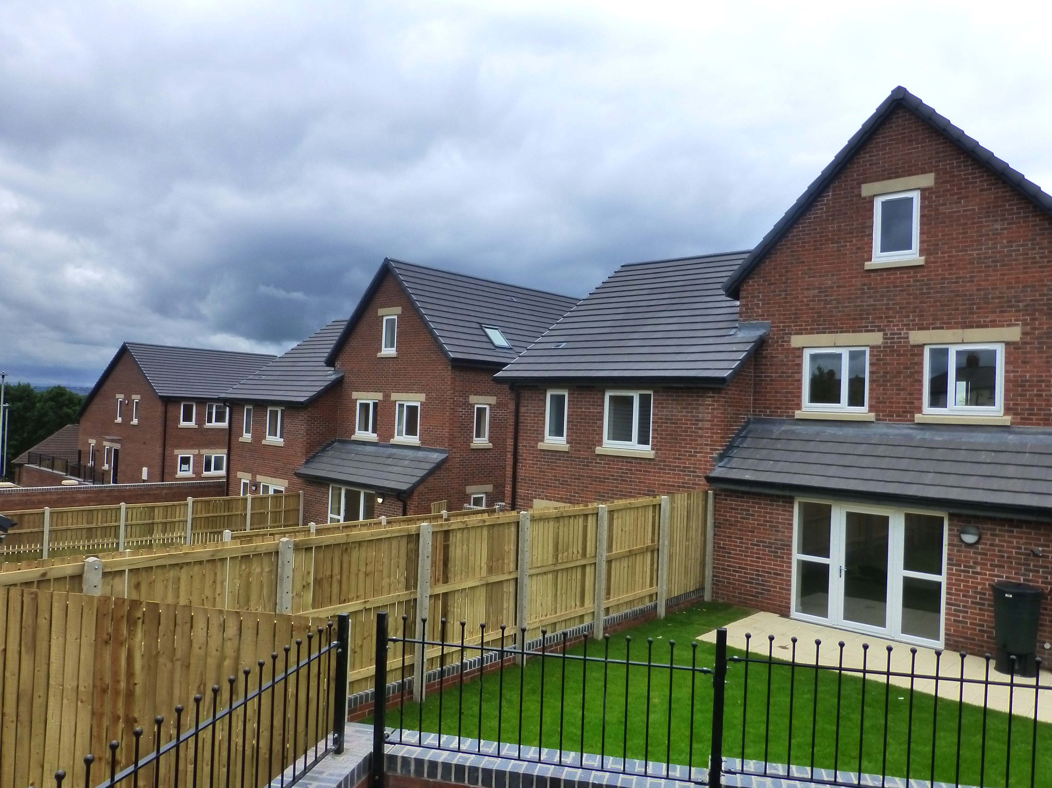
Within a mile of Unity’s housing office the up and coming development on Leopold Street Leeds, available in 2020 will consist of 30, 1 and 2 bedroom homes for people aged over 55, the scheme is being developed in partnership with Chapeltown Co Housing who will have 34 homes at the same site.


Tenant Involvement Activities

Highlights
Members of our tenant scrutiny panel were given a tour of unity business centre
A welcome event was held for all new residents at our new development at Chipesch Way Kippax
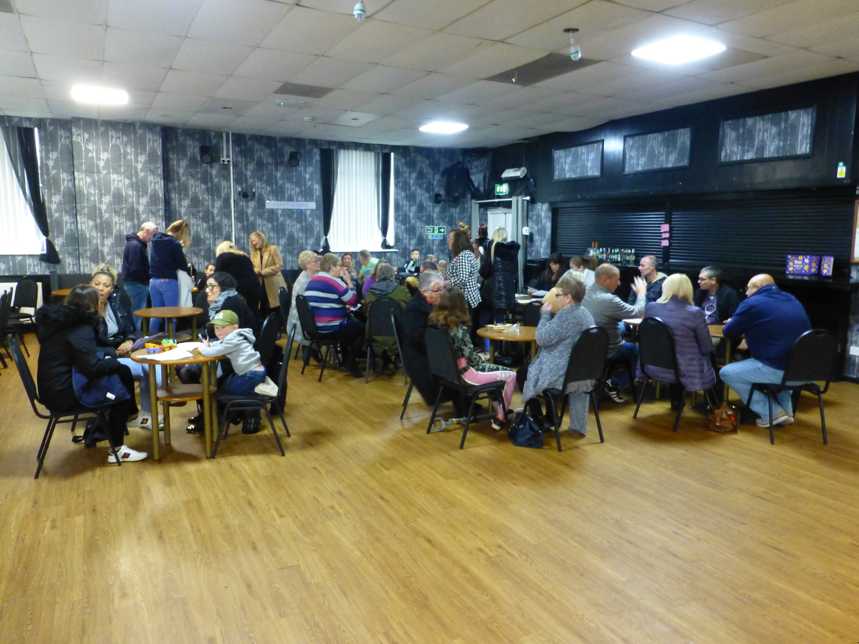

Tenant group members attended a
community walkabout with housing
officers
Children’s activities were provided in the summer for local families

Members of our tenant panel reviewed the services of our contractors Gtd maintenance and bell painting

There was a total of 9 tenant panel meetings held to discuss unity tenant services
Complaints and Compliments


Unity received 19 formal complaints in 2019-20.
Of the 19 complaints 7 complaints were regarding repairs, 4 planned maintenance, 6 staff complaints and 2 were concerning allocations.
100% of complaints were answered at stage one.
66% of complainants were satisfied with the outcome of their complaint.
24 Compliments were recorded in 2019-20.

Complaints Received

2016-17 2017-18 2018-19 2019-20
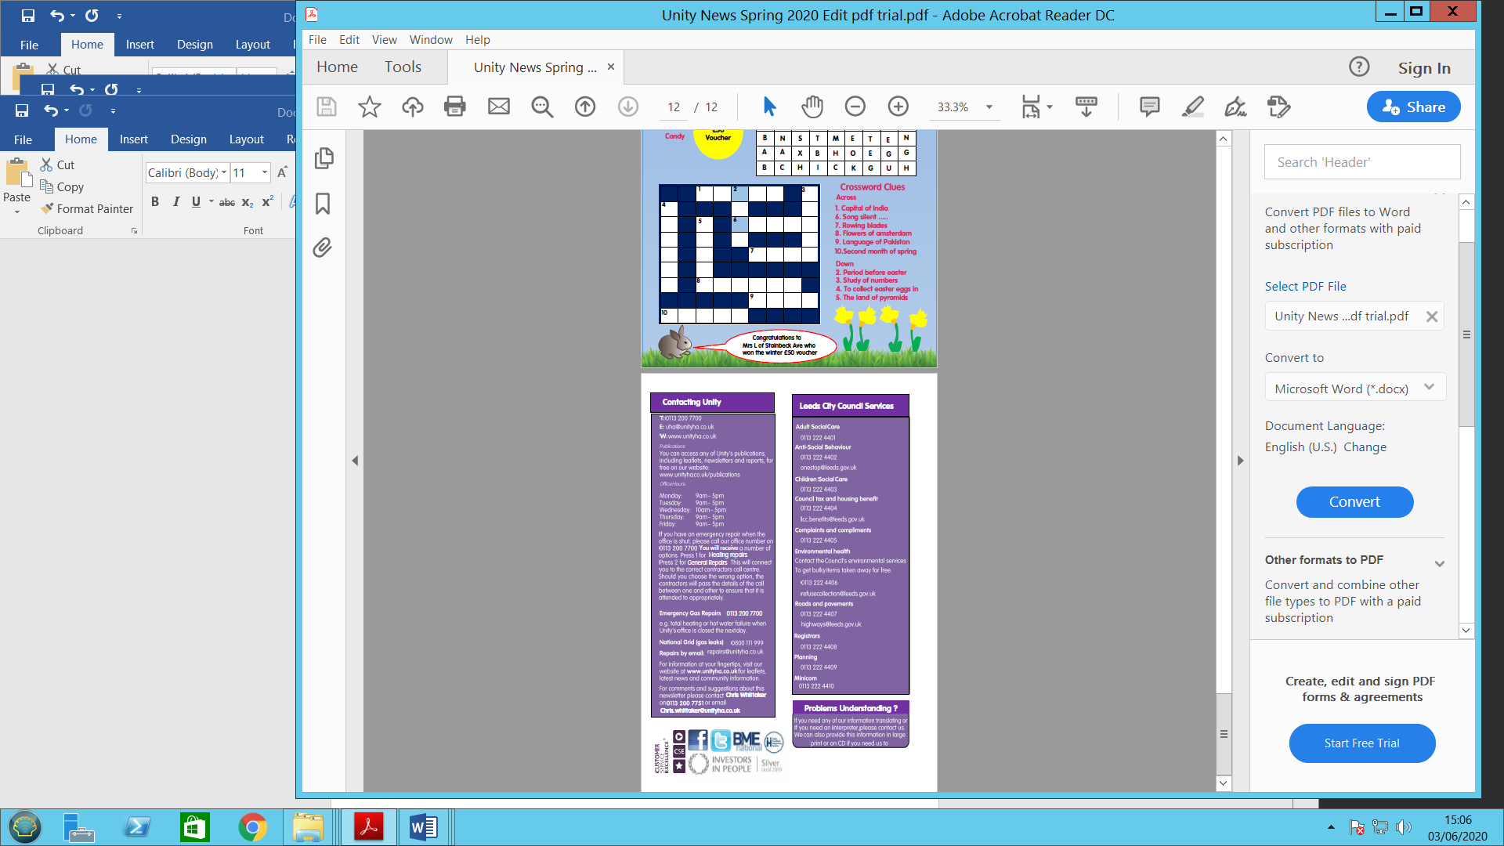
Telephone: 0113 200 7700
Email: uha@unityha.co.uk
Website: www.unityha.co.uk

Publications
You can access any of Unity’s publications including leaflets, newsletters and reports for free on our website:
www.unityha.co.uk/publications

Office Hours:

Monday: 9am -- 5pm
Tuesday: 9am – 5pm
Wednesday: 10am – 5pm
Thursday: 9am – 5pm
Friday: 9am – 5pm

If you have an emergency repair when the
Office is shut, please call our office number on 0113 200 7700 you will receive a number of options. Press 1 for heating repairs, press 2 for general repairs. This will connect you to our contractors GTD Maintenance call centre.

Emergency Gas Repairs 0113 200 7700
E.g. total heating or hot water failure when Unity’s office is closed the next day.

National Grid (gas leaks) 0800 111 999

Repairs by email repairs@unityha.co.uk

For more information, visit our website at
www.unity.co.uk for leaflets, latest news and community information.

For comments and suggestions about this newsletter please contact Chris Whittaker on
0113 2007751 or email chris.whittaker@unityha.co.uk
If you need any of our information translating
Or if you need an interpreter, please contact us.
We can also provide this information in large
Print or on CD if you need this.
Problems Understanding?
Adult Social Care 01484 414933
gatewaytocare@kirklees.gov.uk

Anti-Social Behaviour 01484 221000
safer@kirklees.gov.uk

Child Protection 01484 414950

Council Tax and Benefits 01484 414950
Council.benefits@kirklees.gov.uk

Customer Service Centre 01484 221000
Customer.enquiries@kirklees.gov.uk

Housing Advice 01484 221350
Housing.solutions@kirklees.gov.uk

Kirklees Council Services
Contacting Unity
Leeds City Council Services
Adult Social Care 0113 2224401

Anti-Social Behaviour 0113 222 4402
onestop@leeds.gov.uk

Child Social Care 0113 222 4403

Council Housing 0800 188 4000

Council Tax 0113 222 4404

Environmental Health 0113 222 4406
refugecollections@leeds.gov.uk

Housing Advice 0113 222 4412

Roads and Pavements 0113 222 4407
highways@leeds.gov.uk

Universal Credit 0800 328 5644

